THE ALDE & ORE ASSOCIATION

Registration needed
by 23 July 2023
Your Voice – Your Estuary
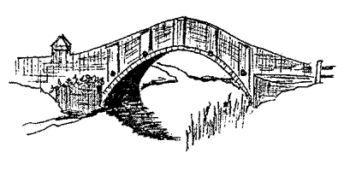

Registered Charity no 1154583

Annual Barbecue Party 2022

ANNUAL BARBECUE PARTY 2023
Chillesford Lodge Estate, Woodbridge, IP12 2AL

Map reference TM390608 (Explorer Map 212)

Blackheath House, Blackheath Estate, Friston, Saxmundham, IP17 1NX
August 2023

Sunday
6
1pm for 1.30pm
Entrance on the A1094 opposite the road to Knodishall
Map reference TM424578

Our annual barbecue is the highlight of the Association’s year and a great occasion to catch up with fellow members.
This year by kind invitation of George and Ali Watson we are returning to the amazing crag outcrop overlooking the upper Butley River reaches as it turns from a maze of narrow channels passing lovely islets to become a navigable river.

Tickets are £25 for adults, £10 for children 6-13 years, and 5 years and under are free.

There will be a hog roast plus salads and a dessert. Please let us know if a non-meat alternative is needed.

There will be a limited bar available, but you are welcome to bring your own wine and beer.

Please bring your own chairs or rugs. Dogs are welcome but please keep them on a lead.

Access by river:
This year there are no holiday Sundays with the perfect tide times for a lunch time but the riverbank at Chillesford should be approachable by about 1.30- 2pm for those of you who like to come by boat.
Access by car:
- Turn south off the Sudbourne to Chillesford Road at the entrance to the private road marked Chillesford Lodge Estate. There is a red brick lodge and small white posts at the entrance.

- After about 2/3 of a mile at the white house, turn right, following the signs to Cooks Barn.

- After 1/3 of a mile at Cooks Barn, continue across the fields and park overlooking the river (traffic marshalls will be there to help)

See the route marked on the map overleaf.

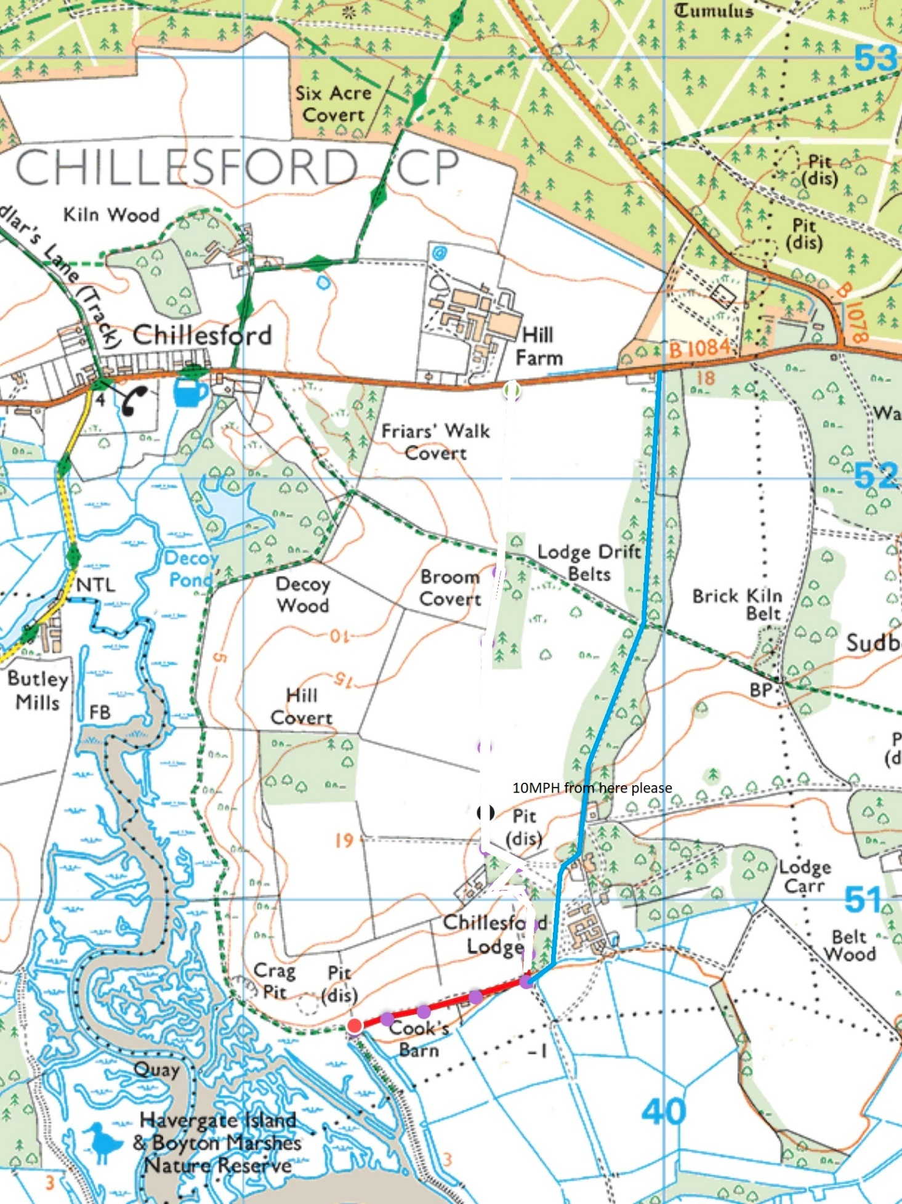
Turn off the Sudbourne/ Chillesford Road here.

Parking here.

Annual Barbecue Registration form

Name
Address
Tel No | Please provide in case of any queries
Email*
* Please provide if you are happy for us to confirm your booking via email.

To keep our administration costs to a minimum, we would like to send you updates about the work and activities
of the Alde and Ore Association by email. If you are happy for us to do this in future, please tick this box

TICKETS: | No. of Tickets | Total Cost
How many adult tickets would you like @ £25 each?
How many children (6-13 years) tickets would you like @ £10 each?
How many children (5 years and under) free tickets would you like? |  | £0.00
TOTAL

Please let us know if you have any special dietary requirements: _________________________________
Can you help?
The success of the barbecue depends on the hard work of volunteers. Please let us know if you can help with:
Car park organisation Salad servers
Clearing up Help on the bar
______________________________________________________________________________

REGISTRATION AND PAYMENT

1. By Electronic Registration and Payment
This method is preferred. Please register by use of the following link: https://forms.gle/f5juKjhg842jqfu29 and payment can be made by BACs to the Association account:

Barclays Bank
Sort Code: 20-98-07
Account number: 20034932

Please quote reference ‘BBQ’ plus your surname. Registration will be confirmed upon receipt of payment.

OR

2. By posting this Form and sending a cheque
Please make your cheque payable to 'The Alde and Ore Association' and post it, along with this form and a stamped self-addressed envelope, to :

The Treasurer
Longview
Leiston Road
Aldeburgh
Suffolk
IP15 5QD Registration will be confirmed upon receipt of payment

